**Who Nmaped me**

***Log Analysis***

**Challenge:**

Can you find the host name of the nmap target?

Attached - nmap.pcap

**Approach:**

That’s a wireshark capture file so we first open it up on wireshark.

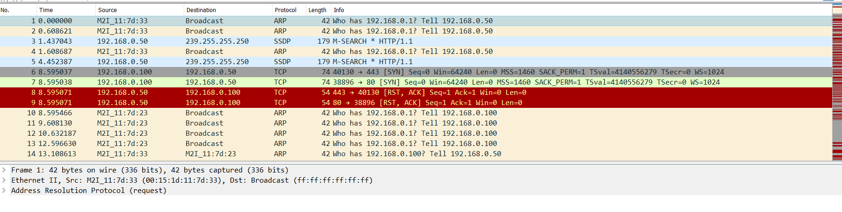

We first need to identify the IP of the target machine. Analyze the packets and you’ll notice a lot of RST ACK packets sent from 192.168.0.50

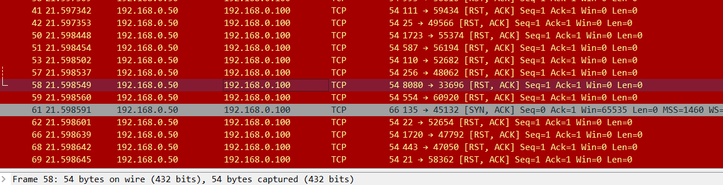

These types of packets are usually sent to close the connection when there is no connection to be found on the port.

Hence we can assume 192.168.0.50 to be the target

We set it in the display filter, look around more in the packets and find this “Host Announcement”, we see the packet has this Host name and hence the flag.

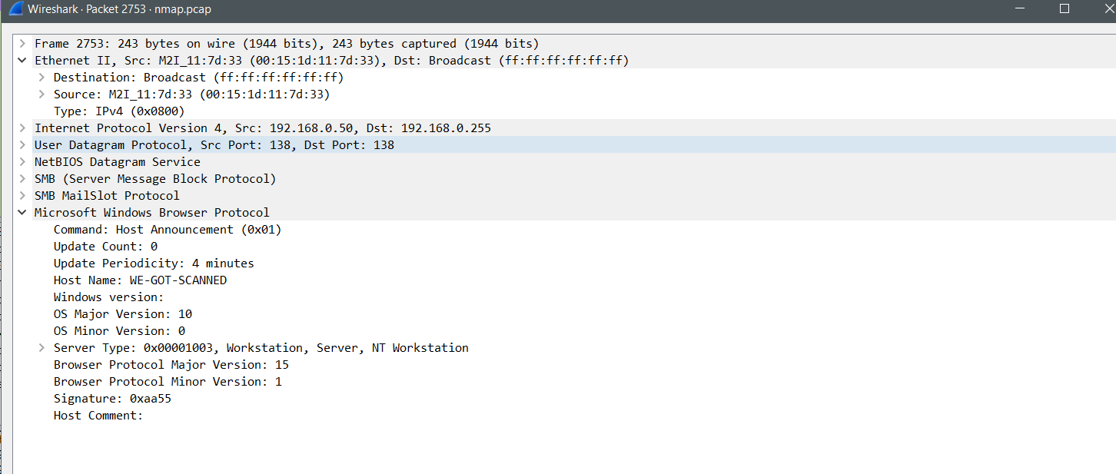

**Flag: WE-GOT-SCANNED**

Congrats!!

Happy Hacking!